Chapter 8 Machines
extra worksheet 2: Why do you weigh more on shag carpet?
Science Understanding Verbal/linguistic
Name: Class: Date:

Want to gain a few kilograms? Just weigh yourself on shag carpet! People have long realised that if they put their bathroom scales onto carpet, particularly with thick pile, they too pile on the weight. The scales read about 10% more than if the scales were placed on a hard floor.
To discover why this happens, we need to look more closely at what is happening inside the scales. Four levers extend inwards from the corners and cross over in its centre. Multiple levers are used to better distribute a person’s weight. When a person stands on the scales, these levers transfer the person’s weight to a spring-loaded metal plate. If we imagine all four levers operating as a single lever, the following illustration shows how they operate inside the scales.
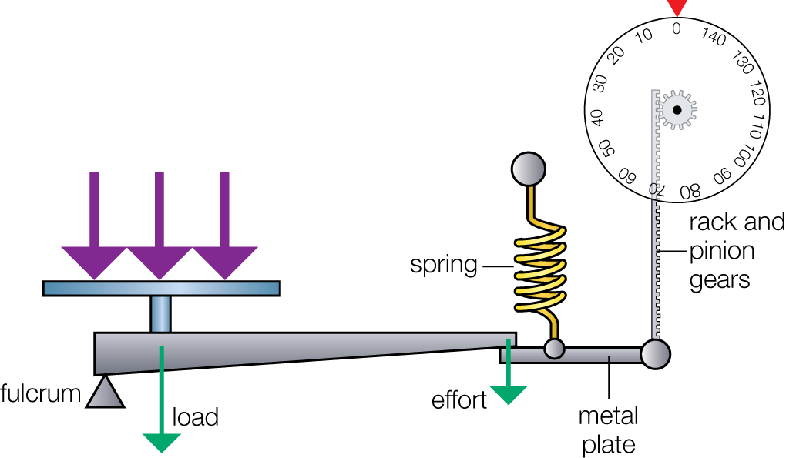
Because the distance from the fulcrum to the load is much shorter than the distance from the fulcrum to the effort, the spring experiences a much smaller force through the levers than if these were not used. Using the levers allows the spring to be much lighter in weight. A rack and pinion system converts the motion of the metal plate into the reading on the circular dial.
Now we see how a set of scales work, so why do they read differently when placed on shag carpet?
On a hard surface, the base of the scales bows downwards by a small amount and the fulcrum tilts in slightly. As a result, the scales record a slightly shorter distance between the load and the fulcrum than they would if the fulcrum was not tilted. On thick carpet, however, this base is supported and stays flat. The corresponding distance between the load and the fulcrum is now slightly increased (see the illustration below). This is increase is translated on the scales as an increase in mass, and the scales register a higher reading. Bathroom scales are actually calibrated on a hard floor, so this is where they give a true reading. So, if you’re ever trying to lose weight, don’t go near shag carpet!

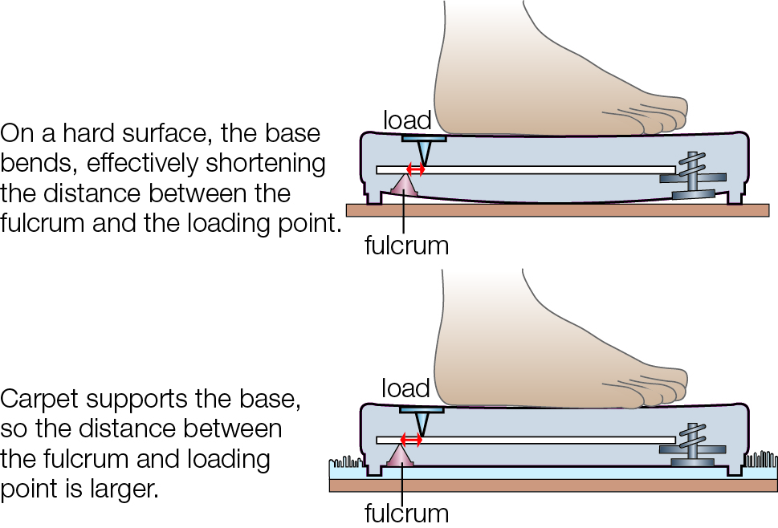

1 State whether the lever in a set of bathroom scales is a first-, second- or third-class lever.

2 Explain why four levers are used instead of a single lever.

3 Describe how using these levers allows a much lighter spring to be used rather than the spring that would be required without the levers.

4 In terms of the distance from the fulcrum to the load and the distance from the fulcrum to the effort, explain why the effort force produced is much smaller than the load force.

5 Describe the role of the rack and pinion gear system in the scales.

6 State whether the distance from the load to the fulcrum is greater when scales are placed on hard floor or shag carpet.

7 Describe the difference this makes to the reading on the scales.

